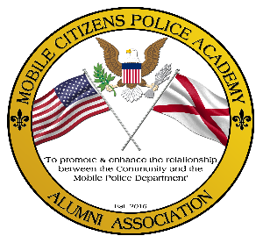**Mobile Citizens Police Academy Alumni Association Application**

We need **You** to keep the MCPAAA a vital part of

"Making Mobile the Safest City in America".

**Join today to become part of something special!!**

The Mission of the Mobile Citizens Police Academy Alumni Association (MCPAAA) is to promote and enhance the relationship between the community and the

Mobile City Police Department

**MCPAAA Members** are eligible to participate in all MCPAAA events and outings, will receive quarterly copies of the MCPAAA Newsletter, are listed in the Membership Directory, and have full voting rights. Membership dues are $20 per person per year.

**Membership is open to:** Graduates of the Mobile Citizens Police Academy and Sworn Officers of the Mobile City Police Department.

**MCPAAA Sustaining Members** are eligible to participate in select MCPAAA events and outings, will receive quarterly copies of the MCPAAA Newsletter and are listed in the Membership Directory. Sustaining Membership dues are a minimum of $50 per year. We appreciate any additional amount you decide to donate.

**Sustaining Membership is open to:** any Citizen or Business that shows interest in supporting the MCPAAA



Please sign and mail completed application with Check or Money order (payable to MCPAAA) to: MCPAAA -1251 Virginia St. Mobile, Alabama 36604. I affirm that the above information is true and accurate, and I authorize MCPAAA to verify any of the above information. Further, I understand that any unauthorized use of membership privileges may result in termination of Membership and revocation of said privileges.